The Birks of Aberfeldy
Robert Burns 1787

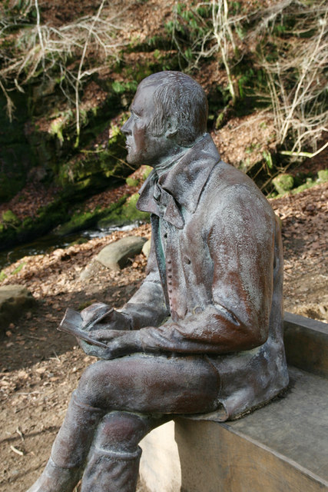
Bony lassie, will ye go,
Will ye go, will ye go;
Bony lassie, will ye go
To the birks of Aberfeldy.

Now Simmer blinks on flowery braes,
And o'er the chrystal streamlets plays;
Come let us spend the lightsome days
In the birks of Aberfeldy.

The little birdies blythely sing
While o'er their heads the hazels hing,
Or lightly flit on wanton wing,
In the birks of Aberfeldy.

The braes ascend like lofty wa's,
The foamy stream deep-roaring fa's,
O'erhung wi' fragrant spreading shaws,
The birks of Aberfeldy.

The hoary cliffs are crown'd wi' flowers,
White o'er the linns the burnie pours,
And rising, weets wi' misty showers
The birks of Aberfeldy.

Let Fortune's gifts at random flee,
They ne'er shall draw a wish frae me;
Supremely blest wi' love and thee,
In the birks of Aberfeldy.

Bony lassie, will ye go,
Will ye go, will ye go;
Bony lassie, will ye go
To the birks of Aberfeldy.

